HW Solution

Chapter 1: Case (One day in the life)

This case shows a glimpse of what it is like to be a project manager. It also underscores that being a project manager is more social than technical and that project managers spend the majority of their time interacting with various people who impact a project.

1. How effectively do you think Rachel spent her day?

You may argue that she is inefficient and does not have control over her time.

You may also argue that this is the nature of the job as expected, and that she is appropriately spending her time managing relations and keeping on top of things that affect the project.

Students with little work experience are often much more critical than those with work experience.

2. What does the case tell you about what it is like to be a project manager?

Rachel’s day underscores three key functions project managers spend their time performing:

a. Building and sustaining interpersonal relations. Project managers have to network and develop good working relations with team members and other project stakeholders.
b. Information gathering and dissemination. Project managers are the information hub for their projects. They are in constant communication with various stakeholders, collecting information from various sources, and sending it to those who have a need to know.
c. Decision-making. Project managers consult with various people to make decisions necessary to complete the project.

Chapter 2: Problems 2-5

2. Two new software projects are proposed to a young, start-up company. The Alpha project will cost $150,000 to develop and is expected to have annual net cash flow of $40,000. The Beta project will cost $200,000 to develop and is expected to have annual net cash flow of $50,000. The company is very concerned about their cash flow. Using the payback period, which project is better from a cash flow standpoint? Why?

Payback = Investment / Annual Savings

Project Alpha: $150,000 / $40,000 = 3.75 years

Project Beta: $200,000 / $50,000 = 4.0 years

Project Alpha is the better payback.

3. A five-year project has a projected net cash flow of $15,000, $25,000, $30,000, $20,000, and $15,000 in the next five years. It will cost $50,000 to implement the project. If the required rate of return is 20 percent, conduct a discounted cash flow calculation to determine the NPV.

 | A | B | C | D | E | F | G | H
1
2 | Exercise 2.3
3 | Net Present Value Example
4
5 | Project 2.3 |  | Year 0 | Year 1 | Year 2 | Year 3 | Year 4 | Year 5
6 | Investment |  | -$50,000
7 | Cash Inflows |  |  | $15,000 | $25,000 | $30,000 | $20,000 | $15,000
8 | Required Rate of Return | 20%
9
10 | NPV = | $12,895 |  | Formula: =C6+NPV(B8,D7:H7)

Since the NPV is positive, accept project.

4. You work for the 3T company, which expects to earn at least 18 percent on its investments. You have to choose between two similar projects. Your analysts predict that inflation rate will be a stable 3 percent over the next 7 years. Below is the cash flow information for each project. Which of the two projects would you fund if the decision is based only on financial information? Why?

Omega |  |  |  |  | Alpha
Year | Inflow | Outflow | Netflow |  | Year | Inflow | Outflow | Netflow
Y0 | 0 | $225,000 | -225,000 |  | Y0 | 0 | $300,000 | -300,000
Y1 | 0 | 190,000 | -190,000 |  | Y1 | $50,000 | 100,000 | -50,000
Y2 | $150,000 | 0 | 150,000 |  | Y2 | 150,000 | 0 | 150,000
Y3 | 220,000 | 30,000 | 190,000 |  | Y3 | 250,000 | 50,000 | 200,000
Y4 | 215,000 | 0 | 215,000 |  | Y4 | 250,000 | 0 | 250,000
Y5 | 205,000 | 30,000 | 175,000 |  | Y5 | 200,000 | 50,000 | 150,000
Y6 | 197,000 | 0 | 197,000 |  | Y6 | 180,000 | 0 | 180,000
Y7 | 100,000 | 30,000 | 70,000 |  | Y7 | 120,000 | 30,000 | 90,000
Total | 1,087,000 | 505,000 | 582,000 |  | Total | 1,200,000 | 530,000 | 670,000

 | A | B | C | D | E | F | G | H | I | J
1
2 | Exercise 2.4a
3 | Net Present Value Example Comparing Two Projects
4
5 | Project Omega |  | Year 0 | Year 1 | Year 2 | Year 3 | Year 4 | Year 5 | Year 6 | Year 7
6 | Required Rate of Return | 18%
7 | Investment |  | -$225,000
8 | Cash Inflows |  |  | -$190,000 | $150,000 | $190,000 | $215,000 | $175,000 | $197,000 | $70,000
9 | NPV = | $119,689 | Formula Project Omega: =C7+NPV(B6,D8:J8)
10
11 | Project Alpha |  | Year 0 | Year 1 | Year 2 | Year 3 | Year 4 | Year 5 | Year 6 | Year 7
12 | Required Rate of Return | 18%
13 | Investment |  | -$300,000
14 | Cash Inflows |  |  | -$50,000 | $150,000 | $200,000 | $250,000 | $150,000 | $180,000 | $90,000
15 | NPV = | $176,525 | Formula Project Alpha: =C13+NPV(B12,D14:J14)
16
17 | NPV comparison: Accept both Omega and Alpha; or select Alpha that has the highest NPV of $176,525
18
19 | Exercise 2.4b
20 | Net Present Value Example Comparing Two Projects (with inflation)
21
22 | Project Omega |  | Year 0 | Year 1 | Year 2 | Year 3 | Year 4 | Year 5 | Year 6 | Year 7
23 | Required Rate of Return | 21%
24 | Investment |  | -$225,000
25 | Cash Inflows |  |  | -$190,000 | $150,000 | $190,000 | $215,000 | $175,000 | $197,000 | $70,000
26 | NPV = | $76,650 | Formula Project Omega: =C24+NPV(B23,D25:J25)
27
28 | Project Alpha |  | Year 0 | Year 1 | Year 2 | Year 3 | Year 4 | Year 5 | Year 6 | Year 7
29 | Required Rate of Return | 21%
30 | Investment |  | -$300,000
31 | Cash Inflows |  |  | -$50,000 | $150,000 | $200,000 | $250,000 | $150,000 | $180,000 | $90,000
32 | NPV = | $129,536 | Formula Project Alpha: =C30+NPV(B29,D31:J31)
33
34 | NPV comparison: Accept both Omega and Alpha; or select Alpha that has the highest NPV of $129,536

5. The Custom Bike Company has set up a weighted scoring matrix for evaluation of potential projects. Below are three projects under consideration.
a. Using the scoring matrix below, which project would you rate highest? Lowest?
b. If the weight for “Strong Sponsor” is changed from 2.0 to 5.0, will the project selection change? What are the three highest weighted project scores with this new weight?
c. Why is it important that the weights mirror critical strategic factors?

68
57
99
85
107
95
66
117
88
116
Part b.
Part a.

a. Rate Project 5 the highest and Project 2 the lowest.
b. Yes. Three highest are Projects 3, 5, and 1. Given the new strong sponsor weight, Project 3 becomes the first choice. However, note that Project 5 is still the near equivalent of Project 3 by the weighting scheme.
c. It is important that the weights mirror critical strategic factors because failure to do so will cause selection of projects that do not contribute the most to the strategic plan.

Chapter 3: Case: Orion Systems

ORION Systems (A)

1. What recommendations would you make to Rosas about organizing the Jaguar project, and why?

- Include manufacturing, quality, and logistical support in the project management structure the design phase.

- Use a dedicated project team to improve the integration and project efficiency.

- Consider concurrent engineering/operation to shorten the project duration.

2. How would you change the organizational chart and master plan to reflect these changes?

- Redraw the master plan to engage in manufacturing and logistical support in parallel to design, to shorten its lead time. Consider the use of start-to start lags.

- Reformulate the composition of the top project management team to better cross-functional integration. Add QA and ILS managers to the project organization.

ORION Systems (B)

1. What are the major changes between this plan and the way ORION has managed projects in the past?

- Enhanced cross-functional integration (especially between design and manufacturing)

- Accelerated project completion time

- Project management now covers the entire design, manufacturing, and delivery process, with Production, ILS, and QA managers as part of the top project management team.

- Expanded responsibilities of the team leaders, responsible for developing and testing of specific subsystems (including subsystem quality and manufacturability, budget, cost and quality). Team leaders will act as project managers for their specific system (deliverable) of the project.

2. How well do you believe these changes deal with the problems identified in Part A?

- Production costs should be reduced because manufacturing issues will be incorporated in the design and development process.

- Quality should be improved since it will be factored directly into the design of new products.

- Customer support should be improved because they will be more actively involved in the design and development phase. Evaluation should enhance their commitment as well as provide them with a head start in preparing documentation and designing training programs.

- Project ownership should be enhanced by insisting that at least half of the personnel work full time on the project. Core group working full time on the project should include team cohesion and productivity.

- Scope creep should be reduced because team leaders are more accountable for budget and schedule. Likewise, the active involvement of professionals from manufacturing, support, and QA should help the design engineers to remain focused on practical considerations.

3. Who is likely to support this plan? Who is not likely to support this plan?

- The design engineers are likely, at least at first, not to be supportive of the plan, because they now must work as partners with manufacturing, QA, and logistical support to complete projects.

- The other groups are likely to be very supportive of the plan since they have much more say over decisions that impact their work. Team leaders should welcome the change as their role has expanded with added responsibility and greater accountability.

Chapter 4: P6

6. Use an example of a project you are familiar with or are interested in. Identify the deliverables and organizational units (people) responsible. How would you code your system? Give an example of the work packages in one of your cost accounts.

Refer to Figure 4.5 on page 115 (5th edition). It should have deliverables, WBS, OBS, WPs, coding scheme, and some cost accounts. This exercise is to reinforce the idea of the WBS/OBS matrix as a method for organizing a database for planning and control. Check the structure to ensure deliverables and work packages are something any project team member could clearly identify and associate with. The coding scheme should be easy to implement.

Chapter 5: Exercise 1

1. Mrs. Tolstoy and her husband, Serge, are planning their dream house. The lot for the house sits high on a hill with a beautiful view of the Appalachian Mountains. The plans for the house show the size of the house to be 2,900 square feet. The average price for a lot and house similar to this one has been $120 per square foot. Fortunately, Serge is a retired plumber and feels he can save money by installing the plumbing himself. Mrs. Tolstoy feels she can take care of the interior decorating.

The following average cost information is available from a local bank that makes loans to local contractors and disperses progress payments to contractors when specific tasks are verified as complete.

24 % | Excavation and framing complete
8 % | Roof and fireplace complete
3 % | Wiring roughed in
6 % | Plumbing roughed in
5 % | Siding on
17 % | Windows, insulation, walks, plaster, and garage complete
9 % | Furnace installed
4 % | Plumbing fixtures installed
10 % | Exterior paint, light fixtures installed, finish hardware installed
6 % | Carpet and trim installed
4 % | Interior decorating
4 % | Floors laid and finished

a. What is the estimated cost for the Tolstoy’s house if they use contractors to complete all of the house?

Estimated total cost for the house is $348,000 (2,900 sq. ft. x $120 per foot).

b. Estimate what the cost of the house would be if the Tolstoys use their talents to do some of the work themselves.

Estimated savings of Serge’s plumbing work and Mrs. Tolstoy’s interior decorating:

Plumbing roughed in | 6% x $348,000 | = | $20,880
Plumbing fixtures installed | 4% x $348,000 | = | $13,920
Interior decorating | 4% x $348,000 | = | $13,920
Total saving |  | = | $48,720

Estimated total cost for the completed house using their talents is $299,280 ($348,000 - $48,720).

Chapter 6: Exercise 19
18.
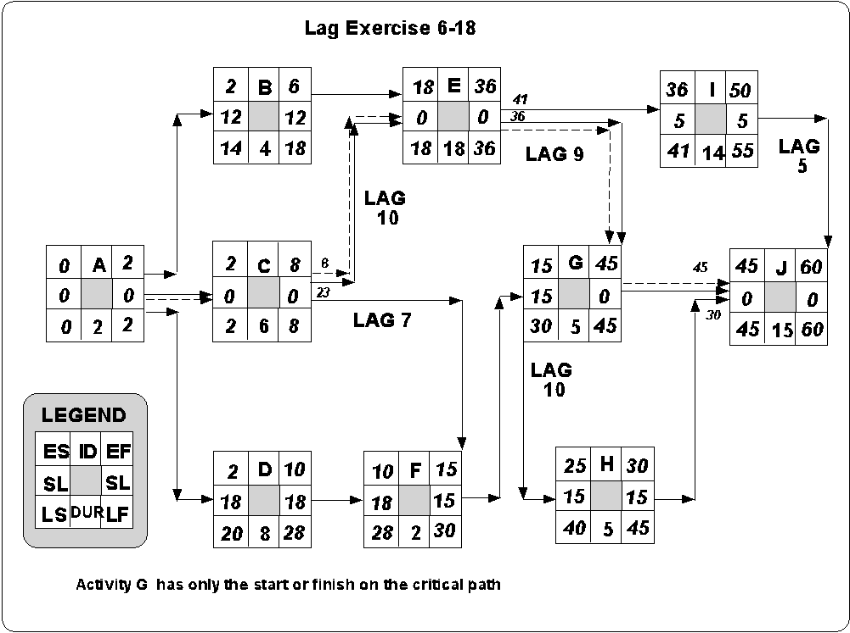

Chapter 7: Case (International Capital, Inc.)

Time in Workdays
Activity | Optimistic | Most likely | Pessimistic | te | Variance
A | 4 | 7 | 10 | 7 | 1
B | 2 | 4 | 8 | 4 | 1
C | 2 | 5 | 8 | 5 | 1
D | 16 | 19 | 28 | 20 | 4
E | 6 | 9 | 24 | 11 | 9
F | 1 | 7 | 13 | 7 | 4
G | 4 | 10 | 28 | 12 | 16
H | 2 | 5 | 14 | 6 | 4
I | 5 | 8 | 17 | 9 | 4
J | 2 | 5 | 8 | 5 | 1
K | 17 | 29 | 45 | 30 | 22

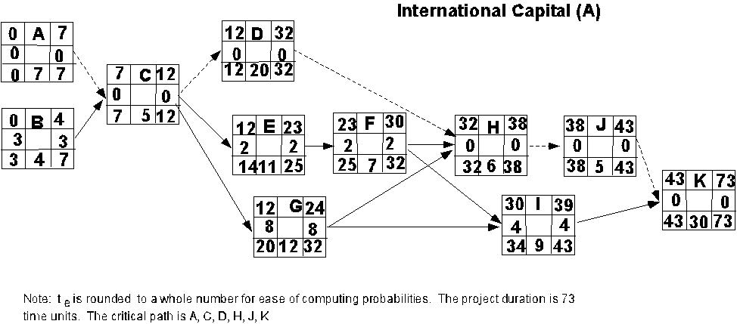

It is possible to compress the project to reach about a 95% chance of hitting the average. This would require compression down to 61 days from the current plan of 73 days. See below.

Chance of average (70) with initial plan (73)

Z = (T_{S} – T_{E}) / Sq. root of sum of variance along CP

Z = (70 – 73) / Sq. root 36 = -3 / 6 = -.5

From Table A7.2 P = .31

This does not meet the 95% chance criterion.

Getting to the average of 70 days and upping the chance of making it would require compressing the project. Compressing to 61 days will improve the chance of meeting the 95% confidence level (but probably increase the risk and lower the real chance of 95 percent).

Z = (70 - 61) / 6 = +9 / 6 = +1.5

From Table A7.2 P = .93

